Pull Tab Challenge

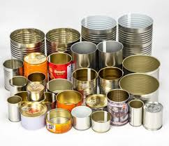 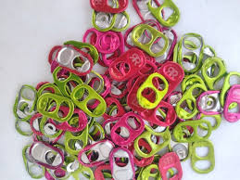

February 1 – March 31

Pull Tabs/Can Tabs

To your teacher

Supports the

Ronald McDonald House